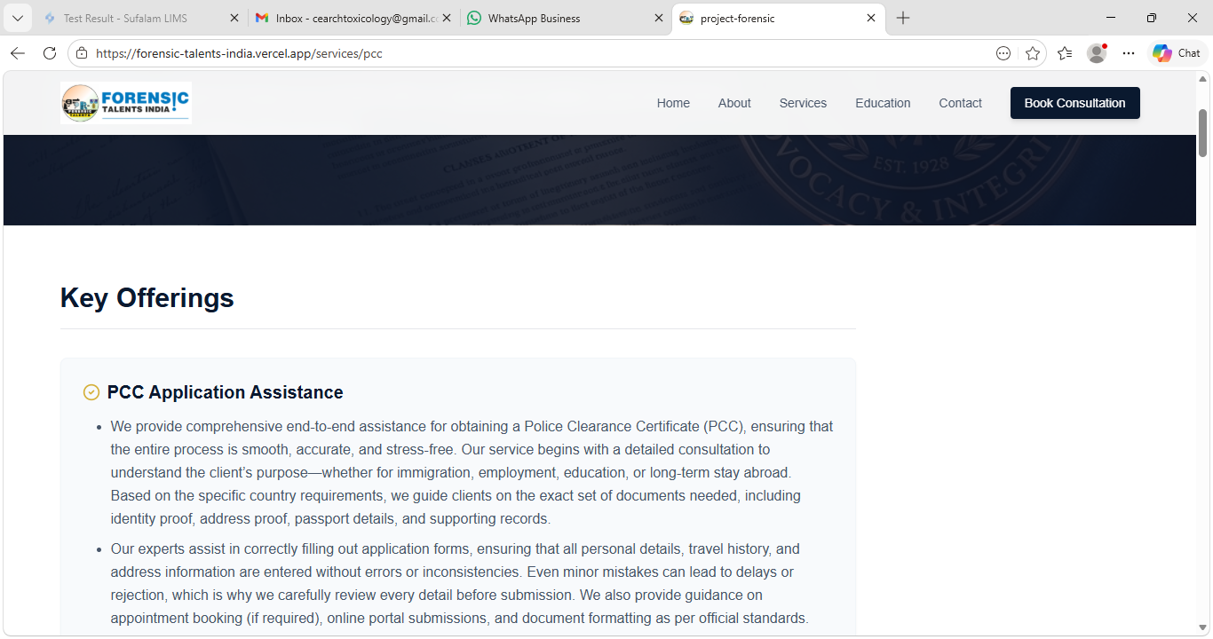
This Portion is seems empty in all services,
If possible put some good visualized gif files or courses or pics or social media visuals, whatever looks professional.

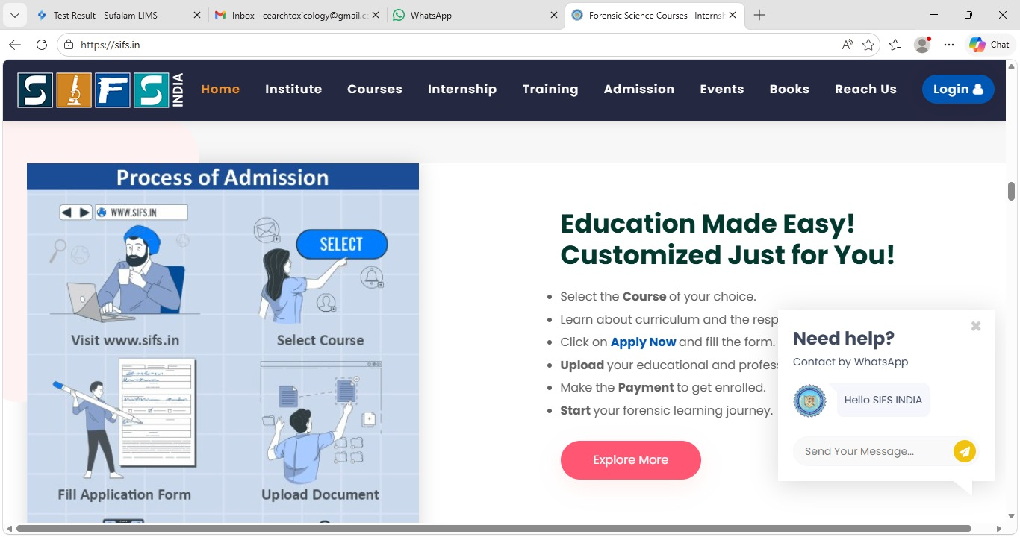
We can add such info graphics to submit the case or inquiry…

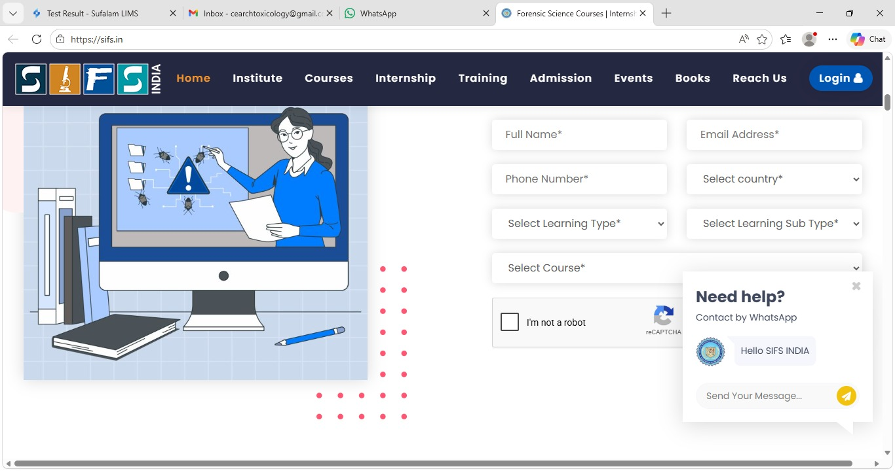
Online Courses we might get participants from different country’s so we can add some more details as shown above images.

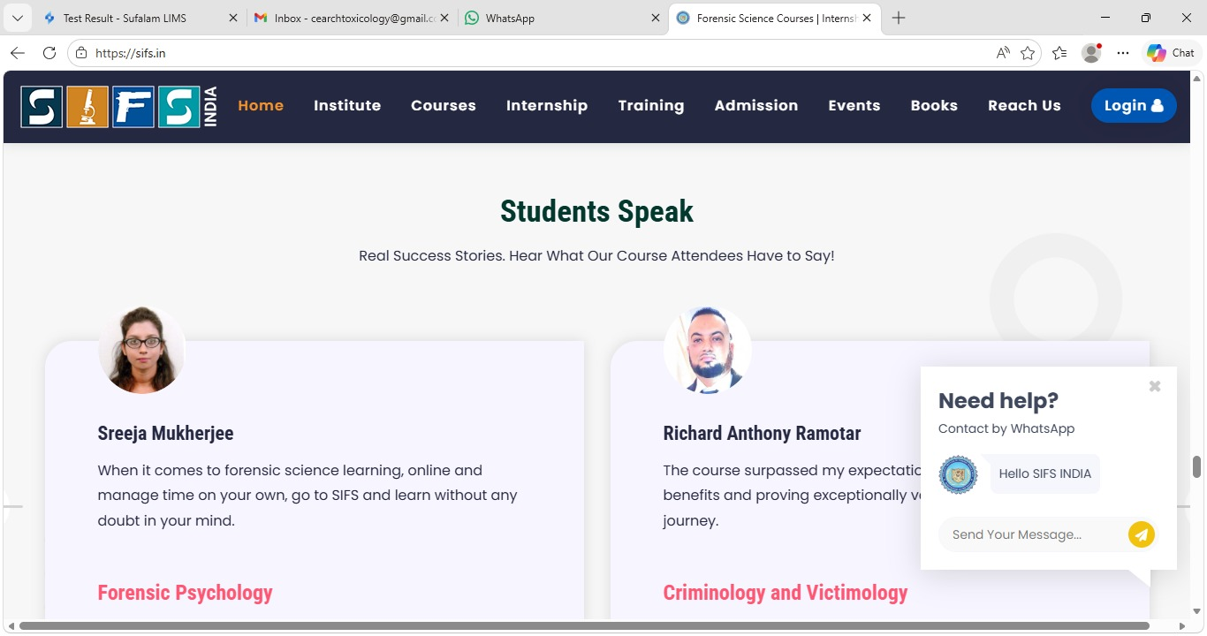
In Education section we can add such things where we can add students review things.

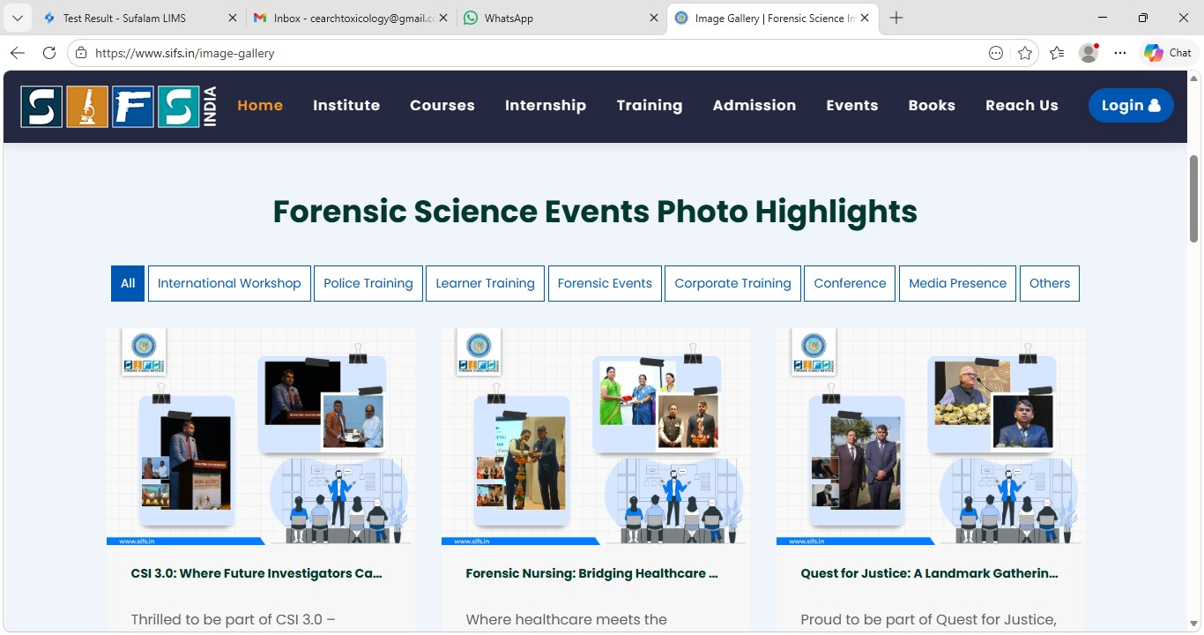
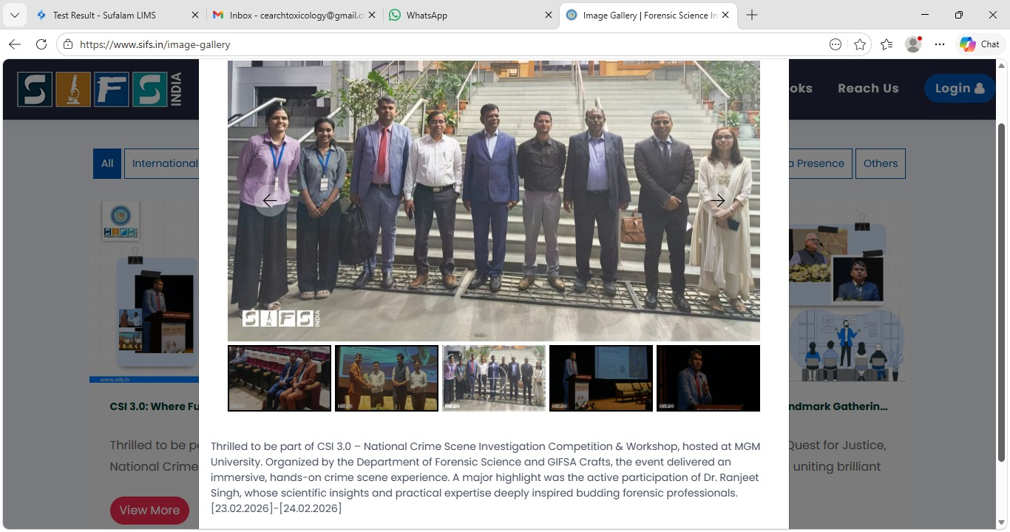
We can add the gallery pics of over events on over website, wherever you feels professional sounds great…

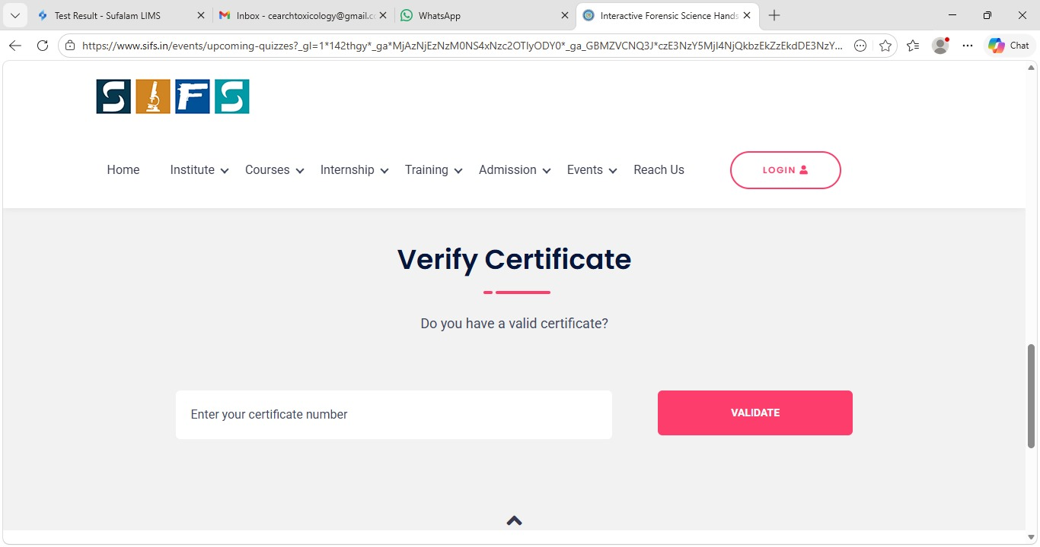
Can we add such things to verifications of the certificates OR it Increase the storage portion in future ?

